Global Food Production Trends and Analysis:
A Comprehensive Study from 1961 to 2023 Using Power BI
Introduction:
ABC Company undertook a comprehensive study of global food production trends from 1961 to 2023, leveraging Power BI for insightful visualizations. The analysis encompassed key agricultural commodities, revealing that total rice production amounted to 269 billion tonnes, while wheat production reached 282 billion tonnes. The study highlighted that tea production stood at 2 billion tonnes, with Africa emerging as the leading producer of green coffee. Additionally, the research underscored a steady rise in wheat, maize, and rice production over the years, with wheat showing the most significant increase.
The project also explored the production volumes of apples, avocados, bananas, and oranges by different regions, identifying Europe and Asia as significant contributors. Maize production demonstrated consistent growth, particularly from the late 1980s onward. The study further indicated that grapes had the highest total production among fruits at 43 billion tonnes, followed by apples, bananas, and oranges. This comprehensive analysis equips ABC Company with valuable insights to better understand global food production trends, aiding strategic decision-making in the agricultural sector.
Scenario 1: Sum of Rice Production (tonnes)
This section prominently displays the total global rice production, amounting to 269 billion tonnes over the period from 1961 to 2023. It highlights the significant volume of rice produced, emphasizing its importance as a staple food crop worldwide.
Scenario 2:Sum of Wheat Production (tonnes)
Highlighting the global wheat production, this section shows a total of 282 billion tonnes produced between 1961 and 2023. This underscores wheat's crucial role in global food security and its widespread cultivation.
Scenario 3: Sum of Tea Production (tonnes)
This section shows a gauge chart illustrating the total tea production, amounting to 2 billion tonnes. The visual emphasizes the scale of tea production compared to other major crops.
Scenario 4:Sum of Coffee, Green Production (tonnes) by Entity
A bar chart depicting the distribution of green coffee production among various entities. Africa, Asia, and America are leading producers, reflecting regional contributions to global coffee Supply.
Scenario 5: Sum of Wheat, Maize, and Rice Production (tonnes) by Year
An area chart showing the annual production trends of wheat, maize, and rice from 1961 to 2023. It highlights the growth trajectories and fluctuations of these essential crops over the years.
Scenario 6: Sum of Apples, Avocados, Bananas, and Oranges Production (tonnes) by Entity
This stacked bar chart illustrates the production volumes of apples, avocados, bananas, and oranges by different entities. It highlights the diverse contributions to global fruit production.
Scenario 7:Sum of Maize Production (tonnes) by Year
A donut chart depicting the yearly maize production distribution across different years. It shows how maize production has evolved, with specific years highlighted for their significant contributions.
Scenario 8: Sum of Grapes, Apples, Bananas, and Oranges Production (tonnes) This bar chart compares the total production volumes of grapes (43 billion tonnes), apples (39 billion tonnes), bananas (32 billion tonnes), and oranges (26 billion tonnes). It provides a comparative view of the global production scales of these popular fruits.
Technical Architecture:
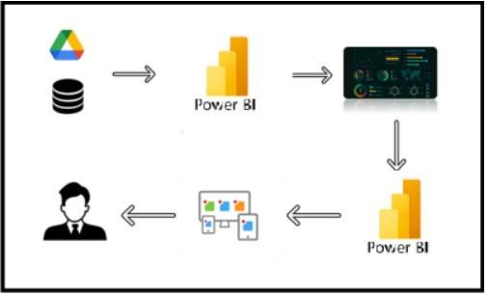

Project Flow
To accomplish this, we have to complete all the activities listed below,
- Data Collectiono Collect the dataset, o Connect Data with Power BI
- Data Preparationo Prepare the Data for Visualization
- Data Visualizationso Visualizations
- Dashboardo Responsive and Design of Dashboard
- Reporto Report Creation
- Performance Testingo Utilization of Data Filters o No. of Calculation fields o No. of Visualizations/Graphs
- Project Demonstration & Documentationo Record explanation Video for project end to end solution o Project Documentation-Step by step project development procedure

Milestone 1: Data Collection & Extraction from Database
Data collection is the process of gathering and measuring information on variables of interest, in an established systematic fashion that enables one to answer stated research questions, test hypotheses, evaluate outcomes and generate insights from the data.
Activity 1: Downloading the dataset Dataset :
https://www.kaggle.com/datasets/rafsunahmad/world-food-production
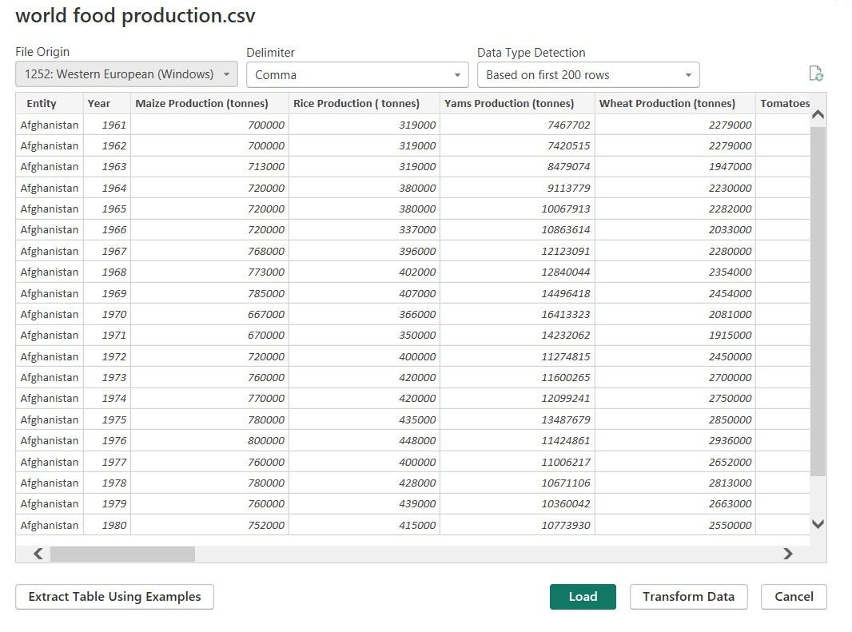
Fig 1.1: World Food Production (CSV File)
Activity 1.1: Understand the data
Data contains all the meta information regarding the columns described in the CSV files
Column Description of the Dataset:
- Entity: Represents the country or region where the food production data is recorded.
- Code: A unique identifier or code for each entity (country or region).
- Year: The specific year for which the data is recorded, ranging from 1961 to 2023.
- Apples_Production (tonnes): The total annual production of
apples measured in tonnes.
- Avocados_Production (tonnes): The total annual production of avocados measured in tonnes.
- Bananas_Production (tonnes): The total annual production of bananas measured in tonnes.
- Coffee_green_Production (tonnes): The total annual production of green coffee measured in tonnes. ● Grapes_Production (tonnes): The total annual production of grapes measured in tonnes.
- Maize_Production (tonnes): The total annual production of maize measured in tonnes.
- Oranges_Production (tonnes): The total annual production of oranges measured in tonnes.
- Rice_Production (tonnes): The total annual production of rice measured in tonnes.
- Tea_Production (tonnes): The total annual production of tea measured in tonnes.
- Wheat_Production (tonnes): The total annual production of wheat measured in tonnes.

Milestone 2: Data Preparation
Activity 1: Prepare the Data for Visualization
Preparing the data for visualization involves cleaning the data to remove irrelevant or missing data, transforming the data into a format that can be easily visualized, exploring the data to identify patterns and trends, filtering the data to focus on specific subsets of data, preparing the data for visualization software, and ensuring the data is accurate and complete. This process helps to make the data easily understandable and ready for creating visualizations to gain insights into the performance and efficiency. Since the data is already cleaned, we can move to visualization.
Data Loading
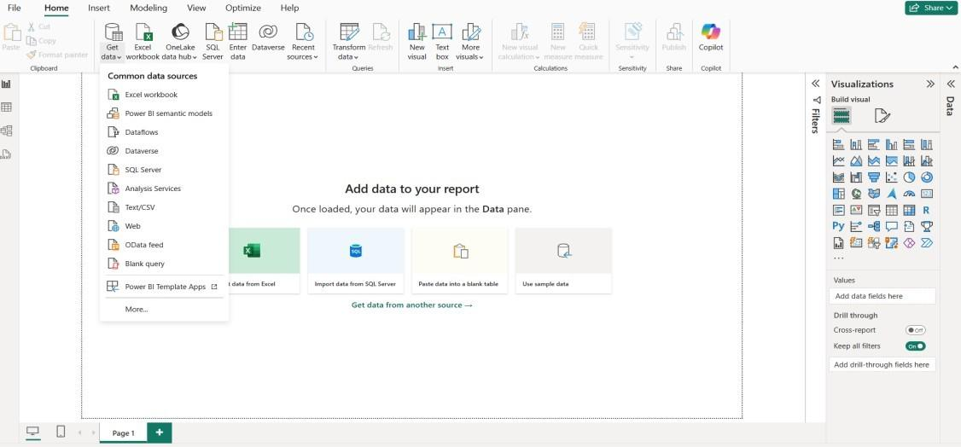
Fig 1.1: Loading Data by selecting Get Data
Fig 1.2: World Food Production CSV File
World Food Production
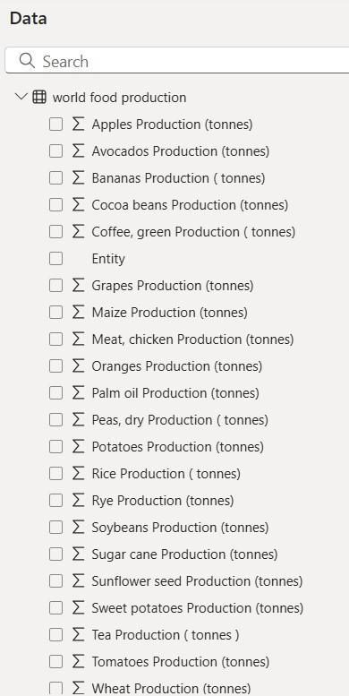
Fig 1.3: The Data in tonnes
Data Cleaning
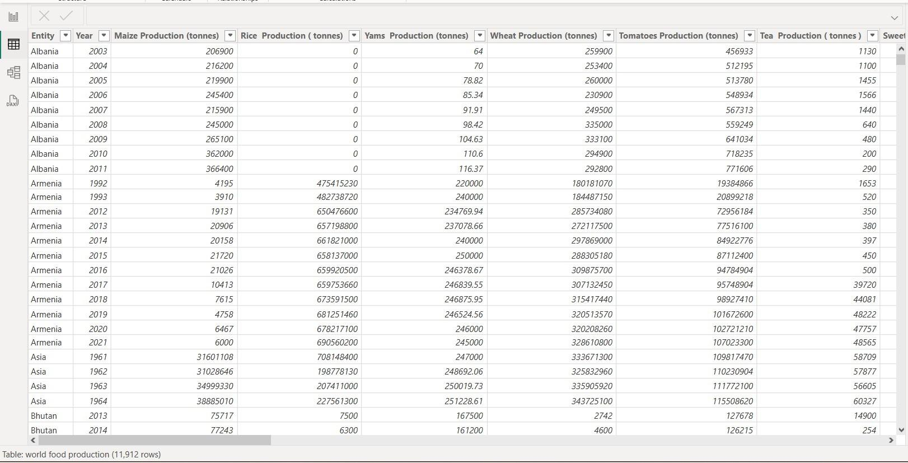
Fig 1.4: The column containing zero values
Cleaning by deleting the zero values
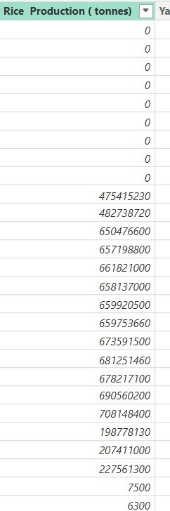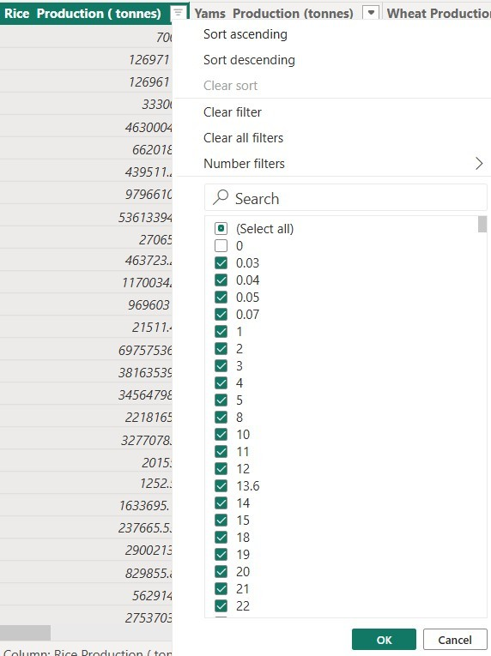

Fig 1.5: Zero values in Rice Fig:1.6: Deselecting the zero values
Production (tonnes)
After cleaning the data by removing zero values
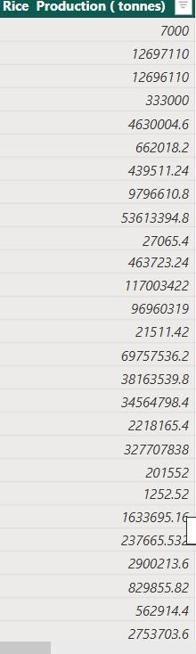
Fig: 1.7: Values without zeros
Converting the Decimal values to Whole numbers because we are using the data in tonnes
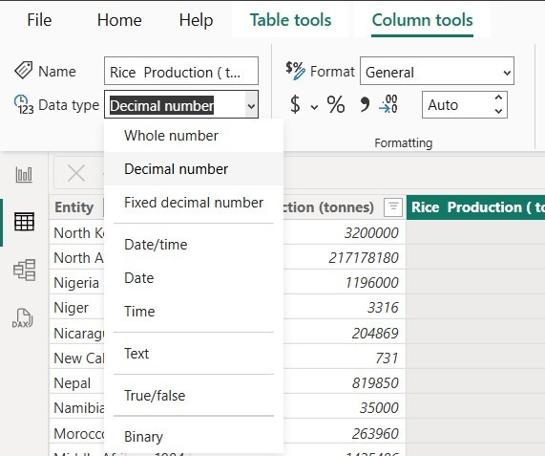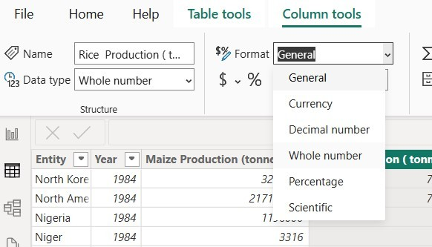

Fig 1.8: Selecting Decimal number and General to convert into Whole numbers
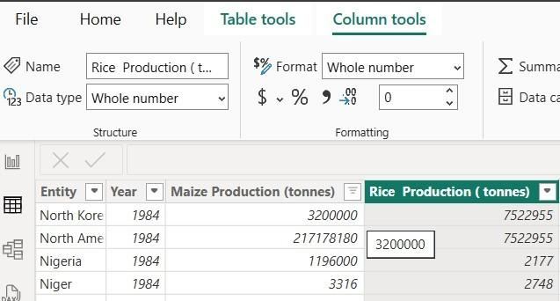
Fig 1.9: After conversion of Whole numbers

Milestone 3: Data Visualization
Data visualization is the process of creating graphical representations of data to help people understand and explore the information. The goal of data visualization is to make complex data sets more accessible, intuitive, and easier to interpret. By using visual elements such as charts, graphs, and maps, data visualizations can help people quickly identify patterns, trends, and outliers in the data.
Activity 1: World Food Production(1961-2023)
Activity 1.1:The total rice production (tonnes)
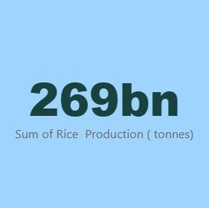
Activity 1.2:The total wheat Productions (tonnes)
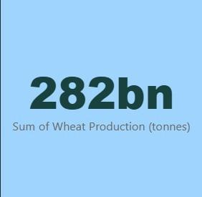
Activity 1.3:The total tea Production (tonnes)
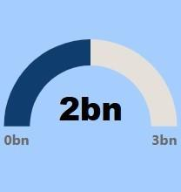
Activity 1.4: Sum of Coffee, Green Production (tonnes) by Entity
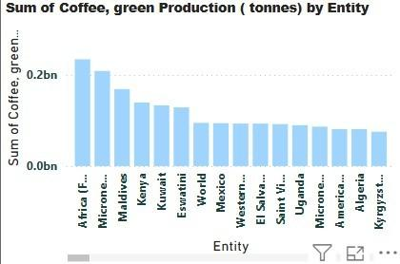
Activity 1.5: Sum of Wheat, Maize, and Rice Production (tonnes) by Year
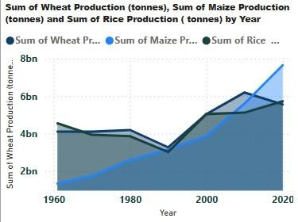
Activity 1.6: Sum of Apples, Avocados, Bananas, and Oranges Production (tonnes) by Entity
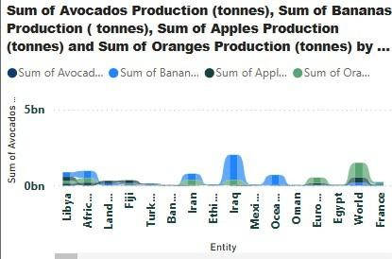
Activity 1.7: The total Maize Production (tonnes) by Year
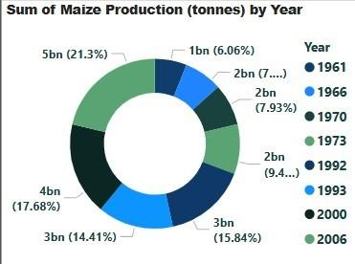
Activity 1.8: Sum of Grapes, Apples, Bananas, and Oranges Production (tonnes)
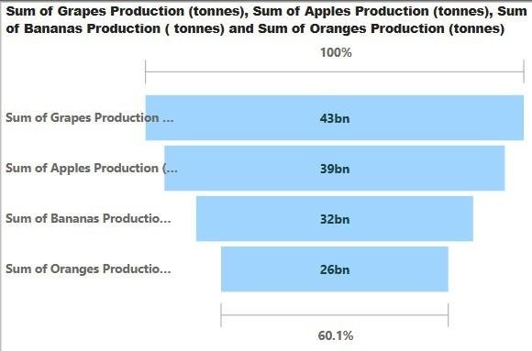

Milestone 4: Dashboard
A dashboard is a graphical user interface (GUI) that displays information and data in an organized, easy-to-read format. Dashboards are often used to provide real-time monitoring and analysis of data and are typically designed for a specific purpose or use case. Dashboards can be used in a variety of settings, such as business, finance, manufacturing, healthcare, and many other industries. They can be used to track key performance indicators (KPIs), monitor performance metrics, and display data in the form of charts, graphs, and tables.
Activity 1:Responsive and Design of Dashboard
Dashboard
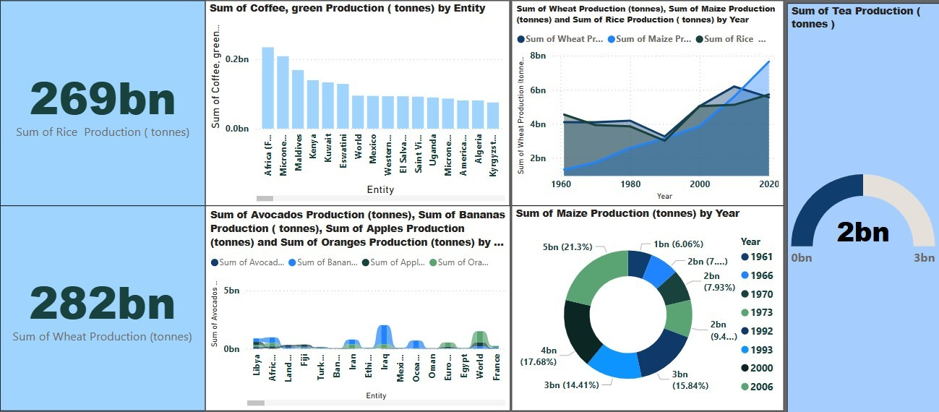

Milestone 5: Report
A report is a comprehensive document that provides a detailed and structured account of data analysis, findings, and insights. It is typically used for in-depth analysis, documentation, and communication of results. Reports are suitable for a diverse audience, including decision-makers, analysts, and stakeholders who need a comprehensive understanding of the data. Activity 1: Design of Report
Designing a report in Power BI involves connecting to data sources, creating visualizations like charts and graphs, customizing their appearance and interactivity, organizing them logically on the canvas, formatting elements for consistency and clarity, and optionally creating dashboards for a summarized view. Throughout the process, it's essential to consider the audience's needs and ensure the report effectively communicates insights from the data. Finally, iterate based on feedback to continually improve the report's design and usefulness.
Report
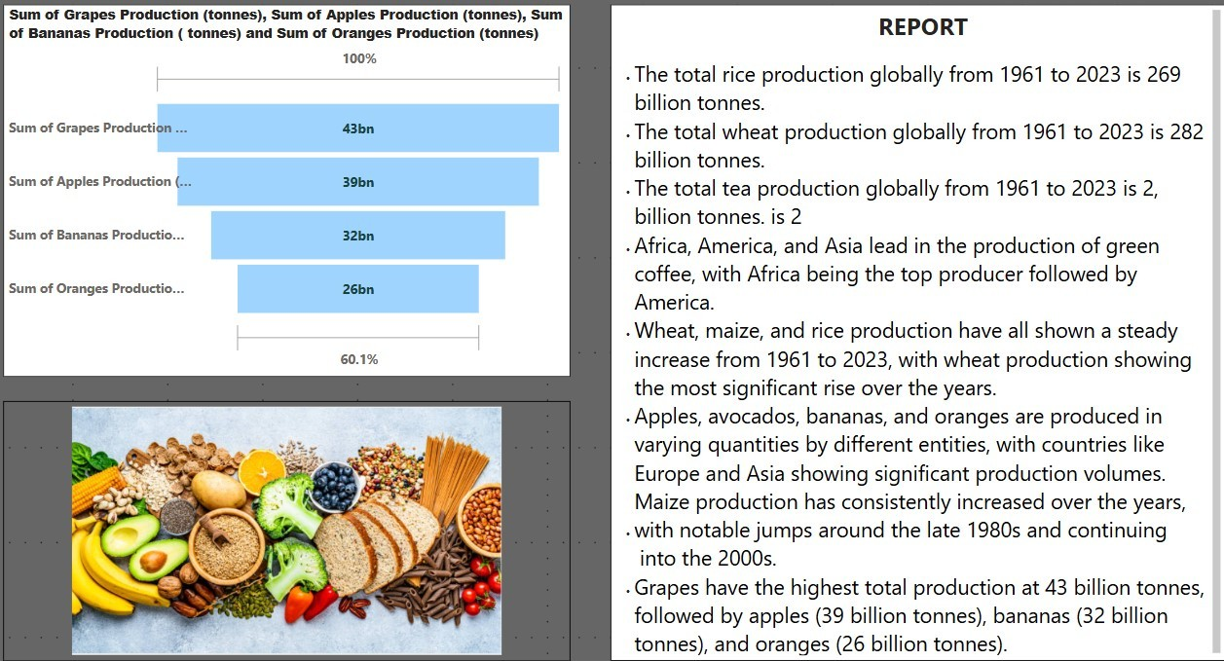

Milestone 6: Performance Testing
Activity 1: Amount of Data Loaded
"Amount of Data Loaded" refers to the quantity or volume of data that has been imported, retrieved, or loaded into a system, software application, database, or any other data storage or processing environment. It's a measure of how much data has been successfully processed and made available for analysis, manipulation, or use within the system.
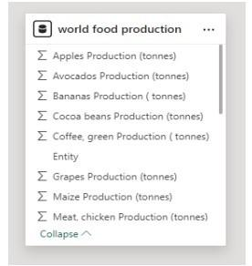
Activity 2: Utilization of Filters
"Utilization of Filters" refers to the application or use of filters within a system, software application, or data processing pipeline to selectively extract, manipulate, or analyze data based on specified criteria or conditions.
Activity 2.1: Selected “Entity” as Filter
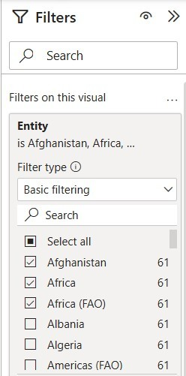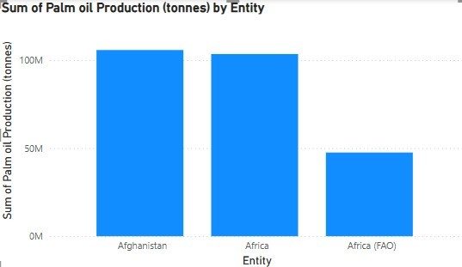

Activity 2.2: Selected “Entity” as Filter
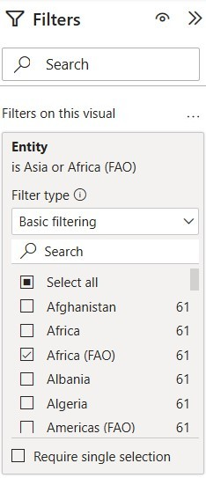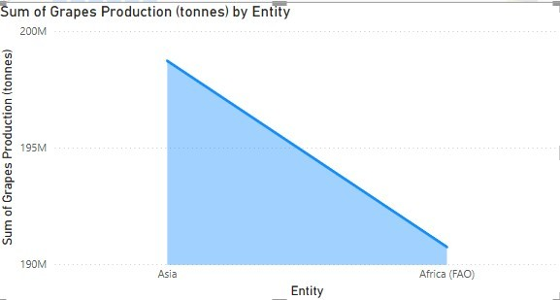

Activity 2.2: No of Visualizations/ Graphs
● The total Oranges Production (tonnes)
● The total Sugar Cane Productions (tonnes)
● The total Soybeans Production (tonnes)
● The total Palm Oil Production (tonnes) by Entity
● The total Grapes Production (tonnes) by Entity
● The total Meat,Chicken Production (tonnes) by Year
● The total Maize Production (tonnes) by Year
● The total Peas, dry Production (tonnes)
● The total Rice Production (tonnes) by Entity
● The total of Grapes, Apples, Bananas, Oranges, Coffee, Avocado Productions (tonnes)
Milestone 7:Project Demonstration & Documentation
Google Drive Link:
https://drive.google.com/drive/folders/1FAMR3WVvZlgvNujXkqLizuW11tPzsnLE
Github Link:
https://github.com/saikumary40/Data-analytics-using-Power-BI.git

